|  |  |  |  |  |  |  |  |  |  |  |
| --- | --- | --- | --- | --- | --- | --- | --- | --- | --- | --- |
| Whitireia Logo_2010   |  | | --- | | **GROUP COVER FORM** |   **Report on Project Management**  **PROGRAMME: Project Management in Information Technology**  **COURSE CODE: IT7x25**  **ASSIGNMENT NUMBER: 3**  **TUTOR: MRS PREMLATHA SAMPATH**  **DATE OF SUBMISSION:**  **DUE DATE:**   |  |  | | --- | --- | | **STUDENT ID** | **NAME** | | **21901423** | **Vibha Chugh** | | **21900847** | **Joan Dias** | | **21900130** | **Mandeep Kaur** |  |  | | --- | | **We Certify that this is the team’s own Work:**  **Student Signatures: Vibha, Joan, Mandeep** | |

**Group Contribution Form**

The purpose of this form is to indicate to the lecturer the contribution each student has made to the overall assignment. It is completed by all group members at a meeting they must arrange on or before the due date.

Course Code: **IT7x25** Semester/Year: **2/2019**

Assignment Number: **3**

|  |  |  |  |  |
| --- | --- | --- | --- | --- |
| **Student Names** | **Student IDs** | **Percentage contribution to the assessment** | **Tasks worked on** | **Signature** |
| **Vibha Chugh** | **21901423** | **33.33%** |  |  |
| **Joan Dias** | **21900847** | **33.33%** |  |  |
| **Mandeep Kaur** | **21900130** | **33.33%** |  |  |
| **Total** |  | **100%** |  |  |



# Executive Summary

Mike Trump Investments (MTI) Real Estate is one of the leading corporate and residential real estate owner and developers with multiple business offices located in Auckland, Wellington, Dunedin, Tauranga and Nelson. The company core business is to manage the residential and commercial properties and maintain the COI compliances on file. MTI collects COI certificates on annual basis for all properties. Due to non-availability of system, company has to maintain all the data in files and on papers. Moreover, the business units are not collaborated due to lack of any system.

Hence, Techie Tribe has suggested an ERP system and web application to overcome these problems. These systems will help to reduce the paper work and manage day to day operational activities smoothly. The system will increase the communication among all the business units and reduce data duplicity by storing data in system. The project should be completed within six months with in budget.

Table of Contents

[Executive Summary 4](#_Toc22552272)

[1.Feasibility Analysis 6](#_Toc22552273)

[1.1Overview 6](#_Toc22552274)

[1.2. Technical feasibility 6](#_Toc22552275)

[1.3. Financial feasibility 6](#_Toc22552276)

[1.3.1. Cost/Benefit Analysis 6](#_Toc22552277)

[1.3.2. Net Present Value 7](#_Toc22552278)

[1.3.3. Payback period 7](#_Toc22552279)

[1.4. Legal & Contractual feasibility 7](#_Toc22552280)

[1.5. Operational feasibility 8](#_Toc22552281)

[2. Methodology Selection & Implementation 8](#_Toc22552282)

[2.1. Scrum Methodology 9](#_Toc22552283)

[3.Discussion 11](#_Toc22552284)

[4.Summary 11](#_Toc22552285)

[7. Appendix 11](#_Toc22552286)

# 1.Feasibility Analysis

# 1.1Overview

Feasibility study has been done to analyse to ensure that project is legally, technical and economical justifiable. MTI Real Estate project feasibility is based on manage the data base centrally, collaborate all business units, manage residential and commercial properties without any compliance issues. The investment has been measured in three aspects such as cost saving, profit volume, data management, communication level, avoid loss of COI data, meet real estate association rules, provide modern facilities to MTI’s employees after implementing the system.

# 1.2. Technical feasibility

The project financial analysis has been done at the time of project initiation to figure out the technical requirement cost such as hardware, software and third-party services. The resources are also aligned in the project with technical skills of web application development such as design, develop & implementation system and test the system on different environment and release on production environment. The technical requirement work of statement has been issued to vendor.

1. Procurement of web ap domain & host server. Developer will develop the web page in word press. SSL certificate will be procured after getting the approval from MTI’s management to secure the web application.
2. Cloud service provider will be finalised after getting bids. MTI’s financial and project management team will meet with the vendor to finalise the prices and for long term service contract. Vendor should have reliable resources with technical skills to manage web application.
3. ERP system integrated with web application will help to reduce the data redundancy and manage the data remotely but the integration of system and security are technical challengeable.
4. MTI’s IT department will be engaged in system deployment & implementation process to get the more feasibility on technical aspects.
5. Routers will be installed in MTI’s building for the system connectivity.

|  |  |  |  |
| --- | --- | --- | --- |
| **Size / Complex** | **Low** | **Medium** | **High** |
| **Small** | Banner Area |  | Database, |
| **Medium** |  | Dashboard | ERP system, |
| **Large** | Load Data | finalise cloud service provider | Integrate security System, web page design |

Figure 1: Task Evaluation

# 1.3. Financial feasibility

MTI Real Estate has given the approval of $60000 on project budget. The web pages content has shared with the management. Any new feature or content will impact on project cost. The project cost will be presented in fortnightly meeting. The project cost is evaluated with the help of NPV, payback period financial methods.

# 1.3.1. Cost/Benefit Analysis

The cost and benefits have been analysed in financial analysis to analyse the profits for next 3 years after implementing the new system. The tangible cost such as hardware, software, license fees or required resources cost have been considered in the financial analysis report. After milestone 2, cost & benefits have been proposed and if any new features or requirement will be added then It will impact on the cost and benefits of project. There is no variation in project cost after analysing on the revised project budget. Below factors in screen shot is considered for the cost benefit analysis.

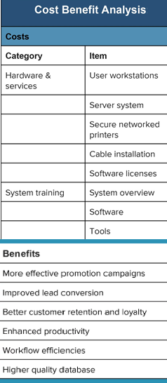

Figure: Cost Benefit Analysis

# 1.3.2. Net Present Value

As per financial analysis the Net Present value for MTI project is 196% with 8% discount rate. The NPV value is in positive with high figure rate which implies that the project is in profits. The project cost is managed by reviewing and analysing old system of MTI. The cost can be reduced by minimize the web app features, use predefined templates in word press but this will impact on user interface. MTI projects will provide benefits at the different time in the future, all costs and benefits of the projects should be viewed in relation to their present value.

# 1.3.3. Payback period

The payback period for MTI project will be start from next year. In first year, there is no profits as it requires time to generate sufficient cash flows to recover its initial cost. Payback period will start from first year and it will continue until three years because of project stability.

# 1.4. Legal & Contractual feasibility

The legal & Contractual feasibility analysis objective is to facilitates the risk management, indicating the risks and obstacles that needs to be addressed with in technical analysis. The project contract has considered other legal factors such as copyright infringement, antitrust legislation, reporting standards (financial & COI data information) and non-disclosure infringement. The system developers and other team members should be aware from the rules that govern the industry. SOX compliance will be reviewed on monthly basis to avoid any variation in the project.

1.4.1. Executing Smart Contract

The contract includes the terms & conditions. The shared network automatically executes the contract and monitors the compliance. The assets such as customer data, COI data and application will be hosted on cloud environment hence the security, License agreement for software and hardware and ethical issues have been considered in the contract.

1.4.2. Web Application compliance

Techie Tribe will consider all the compliance factor related to we app development to implementation. The host and domain server will be procured from reliable vendor and validate all the terms. The cookies and cache should be deleted after using in the web page. Hence, user data will not be misused by the hackers.

# 1.5. Operational feasibility

In the project operational feasibility has been analysed to find the benefits of the proposed system to solve the MTI’s business problems. Operational feasibility helps to analyse how the new erp and web app systems will fit into the current day-to-day operations of MTI.

System analysts will evaluate whether the current work practices and procedures support a new system and how the organizational changes will affect the working lives of those affected by the system. Implementing the new IT/IS project may cause some obstructs and may increase difficulty to the staffs in their day-to-day operation.

* It is not only important to evaluate whether a system can work, but also evaluate whether a system will work. A workable solution might fail because of the end-user or management resistance, such as, how will the working environment of the end-users change, or whether end-users and management can and will adapt to that change

1.6. EnvironmentalFeasibility

# The manual system makes the business environment slower. Hence, the environmental feasibility has been measured in the project to assess the environmental effects or consequence. ERP system design, development, testing and deployment will not affect the business operation of MTI. Moreover, the power backup and resources will align to complete the project on time. The data should be auto saved in ERP system at the time of any entry this will help user to not reword on data in any power cut time. The feature will be considered base on Internal and external environmental factors.

# 2. Methodology Selection & Implementation

.

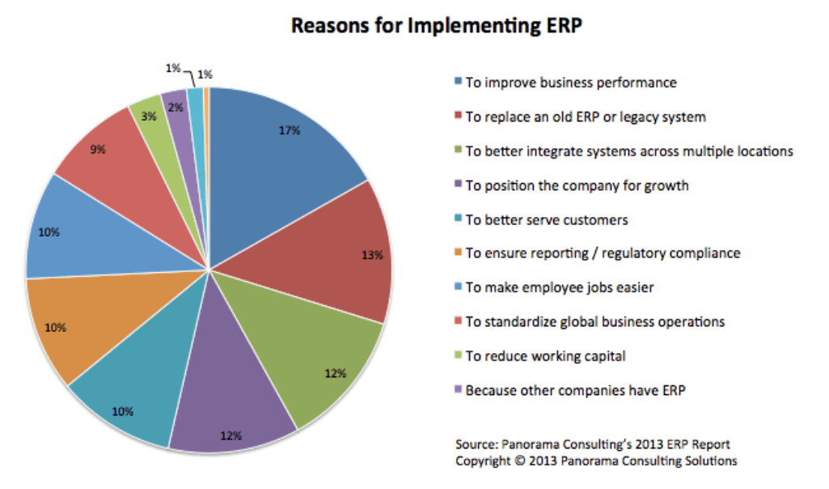

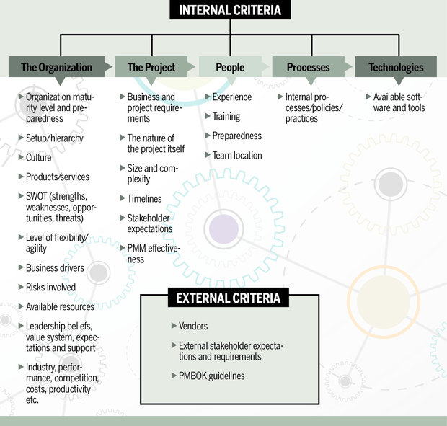

Figure: list of project methodology assessment criteria

# 2.1. Scrum Methodology

2.1.1 Tool/Software for Project Implementation Plan

2.1.1.2 Azure DevOps

2.1.1.1 Project Plan

2.1.1.2. Product Backlog

2.1.1.3. Active Sprints

2.1.1.4. Report

2.1.1.4.1 Sprint Report

2.1.1.4.2 Burndown Chart

2.1.1.4.3 User stories

2.1.1.4.5 Issues

2.2 MTI ERP system

2.2.1. Home Page

2.2.2. Login Page

2.2.3. Category Page

2.2.4. Upload Link

2.2.5. Payment Link

# 3.Discussion

# 4.Summary

6. Reference

# 7. Appendix